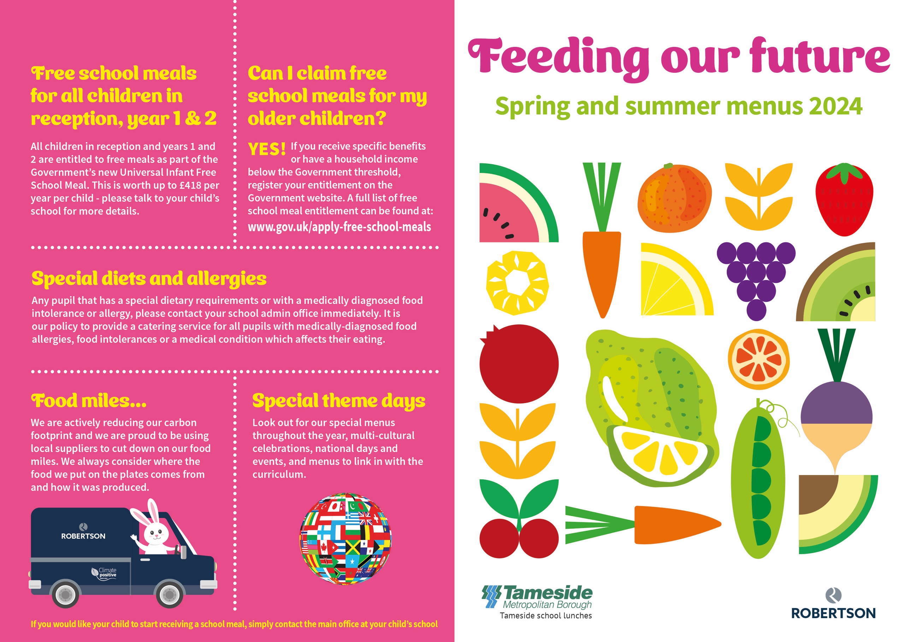

Sausages in gravy  Pizza choice  Sandwich of the day  Jacket potato with choice of filling  Ice cream tub  Fresh fruit, yogurt, cheese and biscuits  Creamed potatoes baked half jacket, sweetcorn, cabbage | Chicken tikka  Homemade cheese flan  Sandwich of the day  Jacket potato with choice of filling  Fruity flapjack  Fresh fruit, yogurt, cheese and biscuits  Savoury rice, creamed potatoes,  baked beans and peas | Roast beef and gravy  Quorn chilli  Sandwich of the day  Jacket potato with choice of filling  Sponge and custard  Fresh fruit, yogurt  Baked new potatoes, boiled rice,  broccoli and carrots | Homemade meat and potato pie  Quorn Mediterranean pasta bake  Sandwich of the day  Jacket potato with choice of filling  Homemade biscuit with orange wedge  Fresh fruit, yogurt  Sweetcorn, green beans | Fish Friday  BBQ Vegetarian sausages  Sandwich of the day  Jacket potato with choice of filling  Fruit muffin  Fresh fruit, yogurt  Chips, mashed potatoes,  mushy peas, baked beans
Turkey burger  Cheese whirl  Sandwich of the day  Jacket potato with choice of filling  Homemade biscuit with orange wedge  Fresh fruit, yogurt, cheese and biscuits  Creamed potato, ½ jacket,  baked beans, carrots | Shepherd’s pie  Katsu Quorn curry with rice  Sandwich of the day  Jacket potato with choice of filling  Fruit jelly  Fresh fruit, yogurt  Sweetcorn, cabbage | Roast chicken, stuffing and gravy  Omelette  Sandwich of the day  Jacket potato with choice of filling  Lemon sponge and custard  Fresh fruit, yogurt  New potatoes, baked jacket wedges,  peas and sweetcorn | Pasta bolognaises.  Homemade cheese and onion pie.  Sandwich of the day  Jacket potato with choice of filling  Ice cream with peaches  Fresh fruit, yogurt, cheese and biscuits  Creamed potatoes, ½ jacket potato, cauliflower, green beans | Fish Friday  Savoury Quorn mince with dumpling  Sandwich of the day  Jacket potato with choice of filling  Paris sandwich  Fresh fruit, yogurt  Chips, new potatoes, garden peas,  baked beans
Beef chilli  Cheese and tomato pizza  Sandwich of the day  Jacket potato with choice of filling  Raspberry bun  Fresh fruit, yogurt, cheese and biscuits  Boiled rice, pasta, sweetcorn, baked beans | Katsu chicken curry with boiled rice  Quorn lasagne  Sandwich of the day  Jacket potato with choice of filling  Jelly and fruit  Fresh fruit, yogurt  Carrots, green beans, salad | Roast turkey with gravy  Cheese whirl  Sandwich of the day  Jacket potato with choice of filling  Chocolate sponge and custard  Fresh fruit, yogurt, cheese and biscuits  New potatoes, mashed potatoes, garden peas, carrots | Baked sausages  Quorn korma curry  Sandwich of the day  Jacket potato with choice of filling  Angel delight  Fresh fruit, yogurt  Boiled rice, Mashed potatoes,  broccoli florets, sweetcorn | Fish Friday  Vegetarian sausage roll  Sandwich of the day  Jacket potato with choice of filling  Arctic roll  Fresh fruit, yogurt  Chips, pasta, mushy peas, baked beans.
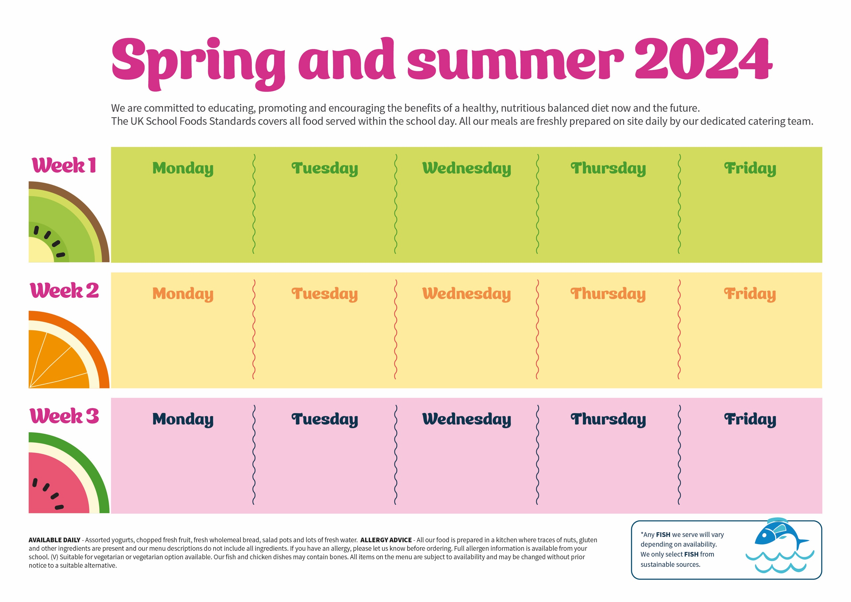
liv

