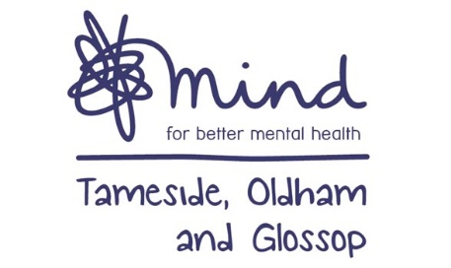



**Local Offer for SEND**



Do you have a query around Autism or ADHD and need

support?

**ADHD /**

**ASD**

**Consultation Offer**

Contact the CAMHS

service on 0161

716

to

3600

access one of the Tuesday Consultation slots with on

e

of the Neuro Specialist Team

. This could be delivered

digitally, over the phone or where there are risks, we

can support face to f

ace.

You can access more than

one consultation appoint if you need to.



KOOTH

**Online Counselling**

and Peer

Support Forum for 11

-

18

year olds

Free to register, no refer

ral needed



School Nurse

**Health Advice Line**

Call

0161

-

366

-

2317

Monday to Friday 9am

-

4

pm

Live information on the Facebook page

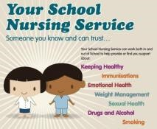

**Early Help**

Neighbourhood Support and

Advice for families in Tameside



**The Hive Drop in**

(8

-

year olds

)

18

TOG Mind

Every Wednesday 4-8pm in Ashton, other localities available

Online support

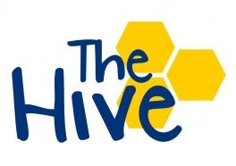

**Mental Health**

**Support in**

**Tameside and**

**Glossop**

[More informatio](https://www.tamesideandglossopccg.org/mentalhealthsupport/children)

[n](https://www.tamesideandglossopccg.org/mentalhealthsupport/children)

for adults and

children’s

mental

health

services

**Families and Young People Can SELF-REFER to the Community Offer – online support and drop ins**